**Project Name: Simplilearn Project phase3**

**Project Developer: Sanchi Srivastava**

**Project detail:**

The project shows Admin view of the store:

1. Admin

The project shows the backend portal of the SportyShoes store. Here admin can

1. Login
2. View Product list
3. Edit Product list
4. Delete the product
5. View product by brand
6. View products by size
7. View list of User
8. Export to PDF

**Dashboard Window:**

* Admin can view dashboard with all the links.

1. Add Items
2. Show Products

* Update
* Remove

1. List products with brands

* Update
* Remove

1. Print store inventory

The project contains Application.properties file for leveraging adding the data configuration.

All the files are shown in alphabetically ascending order.

**Github link**: https://github.com/yashaswiGoswami/thirdproject.git

**Technology used:**

* Spring tool suite
* Spring boot
* Java Server Pages (Jsp)
* JSTL
* H2 database
* Git Bash
* Git Hub

**Core Concepts used:**

* MVC
* Spring Annotation
* Embedded database
* Hibernate
* JPA

**Sprint detail:**

**Sprint 1:**

1. Create dashboard and set UI
2. Create separate JSP pages for different part of pages.

**Sprint 2:**

1. Creating AddItem.jsp, Productlist.jsp and updateitem.jsp pages
2. Create data.sql and put dummy entries.
3. Setup POJO classes inside model package.
4. Hibernate query for data.

**Sprint 3:**

1. Create update entries and remove entries button for every product.
2. Map the url pattern to controller.
3. Add controller code.
4. Set up view

**Scrum Burndown chart:**

Figure : Scrum Burn Down Chart

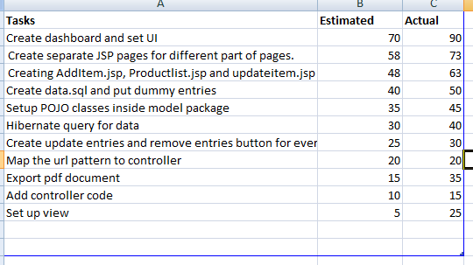

**Conclusion:**

The project is basically delivered within 7 days with the admin part. The project can be secure and bête functioning if Boot security is implemented.